

BT5110 Data Management and Warehousing
AY 2026/27 Semester 1

Group Project
By: Group 5

Name | Matriculation No.
Aishwarya Jayaraman | A0226592Y
Chan Hiu Lok (Reagan) | A0319086X
Phua Zhuo Wei (Zac) | A0234313U
Sara Tan Kwan Ling | A0318609X

2. Schema Translation & Normalization
In response to the feedback on Task 1, the original ER diagram in Figure 1 has been revised; the updated version is shown in Figure 2. Result and Exit are now modelled as relationships between Rider and Stage, and the wins relationship has been split into rider_wins and team_wins. The ER diagram in Figure 2 was then converted into a set of tables to hold the Tour de France data in PostgreSQL. Every entity type became its own table, keyed by the attribute that identifies it in the diagram. Relationships were mapped according to their cardinality. One-to-many relationships are stored as foreign key columns, while the many-to-many relationships (result, rider_wins and team_wins) each have a table of their own. exit is the one exception: although it is one-to-many, it is stored as a separate table. The final schema contains ten relations, linked by foreign keys that mirror the connections in the diagram.

The schema is designed so that invalid data cannot be stored. Data types, NOT NULL and CHECK constraints control the values each column accepts, and foreign keys ensure that every reference points to a row that exists. Rules from the specification that keys cannot capture are enforced by triggers. Values that can be calculated are produced by views instead of being stored. All ten relations are in Boyce–Codd Normal Form (BCNF), so each fact is recorded only once and can be updated in one place.

2.1 Mapping from the ER Diagram
Table 1: Mapping from Figure 2 to relations
Figure 2 Element | Cardinality | Relational Mapping
Country, Team, Rider, Location, Stage, Classification/Award | Entity types | One relation each; key attribute becomes the primary key
represents | Country (0,N) — Team (1,1) | NOT NULL foreign key team.country_code
based in | Country (0,N) — Rider (1,1) | NOT NULL foreign key rider.country_code
hosts | Country (0,N) — Location (1,1) | NOT NULL foreign key location.country_code
consist of | Team (1,N) — Rider (1,1) | NOT NULL foreign key rider.team_name; the team's minimum of one rider (including a leader) is enforced by a deferred trigger
starts, ends | Stage (1,1) — Location (0,N) | NOT NULL foreign keys stage.start_location and stage.end_location
result | Rider (0,N) — Stage (0,N) | Relation result, PK (bib_no, stage_id)
exit | Rider (0,1) — Stage (0,N) | Relation exit, PK bib_no; NOT NULL stage_id
rider_wins | Rider (0,N) — Award (0,N) | Relation rider_wins, PK (award_type, bib_no); trigger allows only awards with is_team = FALSE
team_wins | Team (0,N) — Award (0,N) | Relation team_wins, PK (award_type, team_name); trigger allows only awards with is_team = TRUE
adjusted_time | Derived attribute of result | Not stored; computed in view v_result_adjusted

2.2 Relational Schema
Table 2 lists the ten tables with their attributes, keys and constraints. All times are integers in seconds. Primary keys are underlined and → marks a foreign key and the relation it references. The full DDL, including all triggers and views, can be found in Appendix A.

Table 2: Table Attributes, Keys and Constraints
Relation | Attributes | Constraints
country | country_code,  country_name | country_code is 3 capital letters (ISO 3166-1 alpha-3); country_name NOT NULL UNIQUE
team | team_name,  country_code → country | country_code NOT NULL; must have at least one rider, one of whom is the leader (deferred trigger)
rider | bib_no,  rider_name,  dob,  is_leader,  team_name → team,  country_code → country | bib_no > 0; all attributes NOT NULL; is_leader TRUE for at most one rider per team
location | location_name,  country_code → country | country_code NOT NULL; must start or end at least one stage (trigger)
stage | stage_id,  stage_date,  distance_km,  stage_type,  start_location → location, end_location → location | all NOT NULL; distance_km > 0; stage_type in (flat, hilly, mountain, individual time-trial); start_location ≠ end_location; stage_id ≥ 0
result | bib_no → rider,  stage_id → stage,  position,  finish_time,  bonus,  time_penalty | UNIQUE (stage_id, position); finish_time > 0, bonus ≥ 0, time_penalty ≥ 0; no result at or after the rider’s exit stage (trigger); position ≥ 1 and finish_time − bonus + time_penalty > 0
exit | bib_no → rider,  stage_id → stage,  exit_reason | stage_id, exit_reason NOT NULL
award | award_type,  is_team | five award names only; is_team TRUE only for Best Team
rider_wins | award_type → award,  bib_no → rider | only awards with is_team = FALSE (trigger)
team_wins | award_type → award,  team_name → team | only awards with is_team = TRUE (trigger)

Foreign keys that reference names (team_name, location_name) use ON UPDATE CASCADE, so a renamed team updates every reference in one statement. When a rider is deleted, the rider's results, exit and wins are deleted with them (ON DELETE CASCADE). When a stage is deleted, its results are also removed, but a stage that a rider exited at cannot be deleted until that exit is removed. Rules involving more than one row are checked by triggers; the team-leader and location checks are deferred to the end of the transaction, because a team and its first rider, or a location and its stage, must be inserted together.

Three views compute derived data. v_result_adjusted adds adjusted_time (finish_time − bonus + time_penalty) to each result. v_general_classification ranks riders who have not exited and have a result for every stage raced so far by total adjusted time. v_best_team sums each team’s three fastest adjusted times on every stage and ranks teams first by the number of stages scored, then by the total.

2.3 Normalization
Normalization ensures that each fact is stored in only one place. If all race data were kept in a single table with one row per rider per stage, facts such as a rider’s name, a team’s country and a stage’s date would be repeated across many rows.

This causes update anomalies (changing a team’s country would mean updating every row of every rider in that team), insertion anomalies (a country with no team or rider could not be stored, although the specification requires it) and deletion anomalies (deleting a stage’s results would also remove the stage’s date, locations and distance).

The functional dependencies that hold in such a table, derived from the specification and the cardinalities in Figure 2, are listed in Table 3.

Table 3: Functional Dependencies
FD | Dependency
F1 | bib_no → rider_name, dob, is_leader, team_name, rider_country_code, exit_stage_id, exit_reason
F2 | team_name → team_country_code
F3 | country_code → country_name
F4 | stage_id → stage_date, distance_km, stage_type, start_location, end_location
F5 | location_name → location_country_code
F6 | bib_no, stage_id → position, finish_time, bonus, time_penalty
F7 | stage_id, position → bib_no
F8 | finish_time, bonus, time_penalty → adjusted_time
F9 | country_name → country_code
F10 | award_type → is_team
Role-specific aliases are used in Table 3: rider_country_code, team_country_code and location_country_code refer to country_code in their respective relations, while exit_stage_id refers to exit.stage_id.

To reach Third Normal Form (3NF), the data is divided so that every non-key attribute depends directly on the key of its own table, and not on another non-key attribute. Rider details (F1) form rider, stage details (F4) form stage, and the attributes that depend on both a rider and a stage (F6) form result. The transitive dependencies are removed by giving team details (F2) their own table, team, and likewise country (F3) and location (F5), so that a team’s country or a country’s name is no longer repeated for every rider. adjusted_time (F8) depends on other non-key attributes, so it is not stored and is calculated in a view instead.

BCNF further requires that the left-hand side of every non-trivial dependency is a candidate key of its table. Every determinant in each of the ten tables is a candidate key: country_code and country_name in country, (bib_no, stage_id) and (stage_id, position) in result, and the single key in each of team, rider, location, stage, exit and award, while rider_wins and team_wins consist only of their key. All ten tables are therefore in BCNF. Two design choices were made for reasons other than normal form. Exit details could have been kept in rider without breaking BCNF, since bib_no determines them, but they are stored in a separate exit table so that rider does not carry exit columns that would be empty for most riders. Award winners are split into rider_wins and team_wins rather than kept in a single wins table, which would need nullable bib_no and team_name columns and could not have a complete primary key. If such a table also recorded a winning rider's team, bib_no → team_name would hold there without bib_no being a key, which would violate BCNF.

The decomposition is lossless, because each split leaves a shared attribute that is the key of one table and a foreign key in the other. It also preserves dependencies. F2–F7, F9 and F10 are each enforced by a primary key or unique constraint within a single table. F1 is split across two tables: the rider details are enforced by the key of rider, and the exit details by the key of exit, which is also bib_no. F8 is not stored, because adjusted_time is calculated in a view.

2.4 Key Design Decisions
Each entity in Figure 2 is given its own table so that it can exist independently of the others. For example, a country can be stored even if no team or rider is registered to it. One-to-many relationships are represented as foreign keys rather than separate tables, which keeps the schema simple and avoids unnecessary joins.
The many-to-many relationships each become a table of their own. The result relationship becomes the result table, keyed by (bib_no, stage_id), as each rider has at most one result per stage. rider_wins and team_wins become tables keyed by the award and its winner, so a rider or team can win several awards and an award can have several winners.
The exit relationship is one-to-many, with Rider (0,1) and Stage (0,N), but it is stored as a separate exit table rather than as columns in rider. Only a small number of riders withdraw, so exit_stage_id and exit_reason columns in rider would be empty for most rows. The exit table holds a row only for riders who actually exit. Since each rider can exit at most once, bib_no alone is its primary key.
The is_team attribute of Classification/Award records whether an award is won by a team or by a rider. Triggers check it so that only rider awards appear in rider_wins and only team awards appear in team_wins.
Finally, derived values such as adjusted_time and the overall standings are not stored. Storing them would introduce dependency F8 and risk them becoming outdated whenever a bonus or penalty is corrected. Computing them in views ensures they always reflect the current results.
2.5 Assumptions
All references and constraints are inferred from the coursework instructions as the primary source. The official Tour de France website constraints are not used. For example, we are not using the full list of awards available on the website but only the following awards: General Classification, Points Classification, King of the Mountains, Young Rider and Best Team.

The stage_id attribute is taken to be the stage number, so it also reflects the order of the race; a value of 0 is allowed so that a prologue can be recorded. This ordering is used to check that no results are stored for a rider from the stage at which they exit.

Riders who finish together may share the same finish time, but each is given a distinct position reflecting the order in which they crossed the line, so position is unique within a stage.

The Best Team award follows the official Tour de France team classification. On each stage, the adjusted times of a team's three fastest riders are added together, and these stage totals are summed across the race. A team must have at least three riders finish a stage for that stage to count towards its total.
Figure 1: Original ER Diagram
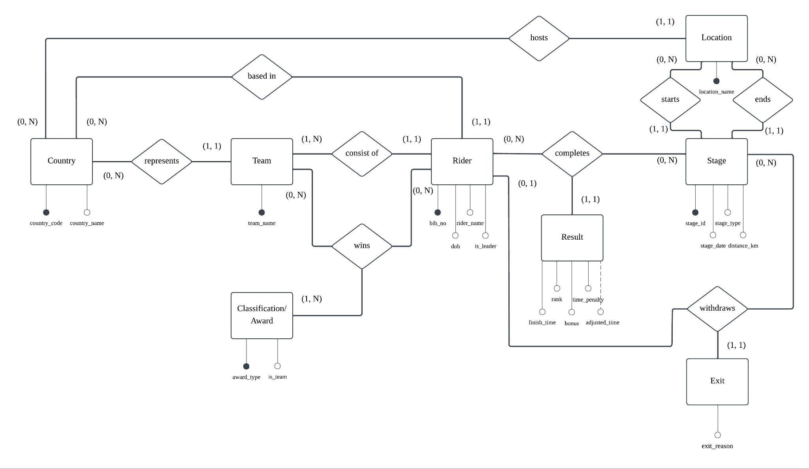

Figure 2: Revised ER Diagram
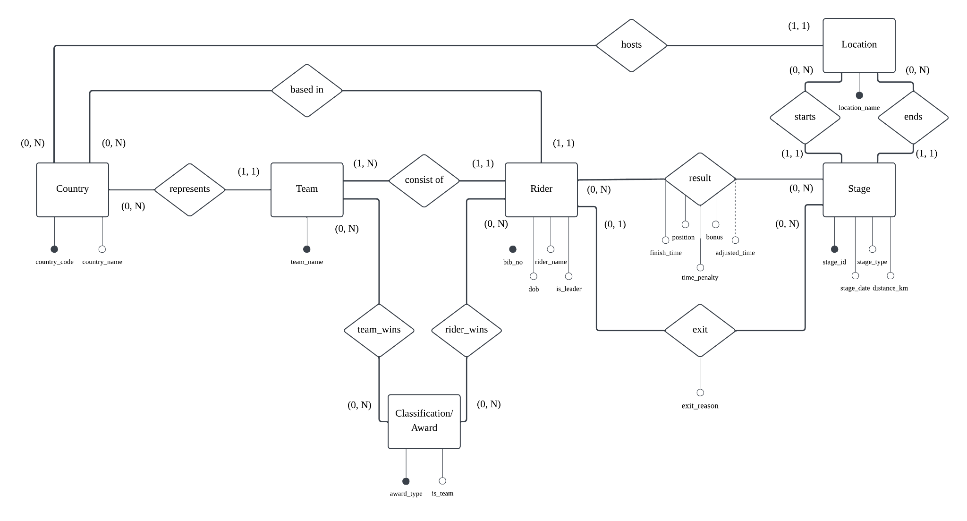

Appendix A: Schema Translation

DROP VIEW IF EXISTS v_best_team, v_general_classification, v_result_adjusted CASCADE;
DROP TABLE IF EXISTS team_wins, rider_wins, award, exit, result, stage, location, rider, team, country CASCADE;

-- 1. Create entity tables
CREATE TABLE country (
country_code CHAR(3) PRIMARY KEY
CHECK (country_code ~ '^[A-Z]{3}$'), -- ISO 3166-1 alpha-3
country_name VARCHAR(100) NOT NULL UNIQUE -- candidate key
);

CREATE TABLE team (
team_name VARCHAR(100) PRIMARY KEY,
country_code CHAR(3) NOT NULL REFERENCES country(country_code)
);

CREATE TABLE rider (
bib_no INT PRIMARY KEY CHECK (bib_no > 0),
rider_name VARCHAR(100) NOT NULL,
dob DATE NOT NULL,
is_leader BOOLEAN NOT NULL DEFAULT FALSE,
team_name VARCHAR(100) NOT NULL REFERENCES team(team_name) ON UPDATE CASCADE,
country_code CHAR(3) NOT NULL REFERENCES country(country_code)
);

CREATE UNIQUE INDEX one_leader_per_team ON rider(team_name) WHERE is_leader; -- At most one leader per team

CREATE TABLE location (
location_name VARCHAR(100) PRIMARY KEY,
country_code CHAR(3) NOT NULL REFERENCES country(country_code)
);

CREATE TABLE stage (
stage_id INT PRIMARY KEY CHECK (stage_id >= 0), -- stage number = race order
stage_date DATE NOT NULL,
distance_km NUMERIC(5,1) NOT NULL CHECK (distance_km > 0),
stage_type VARCHAR(25) NOT NULL
CHECK (stage_type IN ('flat','hilly','mountain','individual time-trial')),
start_location VARCHAR(100) NOT NULL REFERENCES location(location_name) ON UPDATE CASCADE,
end_location VARCHAR(100) NOT NULL REFERENCES location(location_name) ON UPDATE CASCADE,
CHECK (start_location <> end_location)
);

CREATE TABLE award (
award_type VARCHAR(40) PRIMARY KEY
CHECK (award_type IN ('General Classification','Points Classification',
'King of the Mountains','Young Rider','Best Team')),
is_team BOOLEAN NOT NULL,
CHECK (is_team = (award_type = 'Best Team'))
);

-- 2. Create relationship tables
CREATE TABLE result (
bib_no INT NOT NULL REFERENCES rider(bib_no) ON DELETE CASCADE,
stage_id INT NOT NULL REFERENCES stage(stage_id) ON DELETE CASCADE,
position INT NOT NULL CHECK (position >= 1),
finish_time INT NOT NULL CHECK (finish_time > 0), -- seconds
bonus INT NOT NULL DEFAULT 0 CHECK (bonus >= 0), -- seconds
time_penalty INT NOT NULL DEFAULT 0 CHECK (time_penalty >= 0),
PRIMARY KEY (bib_no, stage_id),
UNIQUE (stage_id, position), -- one rider per position
CHECK (finish_time - bonus + time_penalty > 0)
);

CREATE TABLE exit (
bib_no INT PRIMARY KEY REFERENCES rider(bib_no) ON DELETE CASCADE,
stage_id INT NOT NULL REFERENCES stage(stage_id),
exit_reason VARCHAR(255) NOT NULL
);

CREATE TABLE rider_wins (
award_type VARCHAR(40) REFERENCES award(award_type),
bib_no INT REFERENCES rider(bib_no) ON DELETE CASCADE,
PRIMARY KEY (award_type, bib_no)
);

CREATE TABLE team_wins (
award_type VARCHAR(40) REFERENCES award(award_type),
team_name VARCHAR(100) REFERENCES team(team_name) ON UPDATE CASCADE ON DELETE CASCADE,
PRIMARY KEY (award_type, team_name)
);

-- 3. Add constraints
-- (a) Every team has at least one rider and exactly one of its riders is the leader.
CREATE OR REPLACE FUNCTION chk_team_has_leader() RETURNS trigger AS $$
DECLARE t VARCHAR(100);
BEGIN
IF TG_TABLE_NAME = 'team' THEN t := NEW.team_name; ELSE t := OLD.team_name; END IF;
IF EXISTS (SELECT 1 FROM team WHERE team_name = t)
AND NOT EXISTS (SELECT 1 FROM rider WHERE team_name = t AND is_leader) THEN
RAISE EXCEPTION 'Team % must have at least one rider, one of whom is the leader', t;
END IF;
RETURN NULL;
END $$ LANGUAGE plpgsql;

CREATE CONSTRAINT TRIGGER team_needs_leader
AFTER INSERT ON team DEFERRABLE INITIALLY DEFERRED
FOR EACH ROW EXECUTE FUNCTION chk_team_has_leader();

CREATE CONSTRAINT TRIGGER rider_change_keeps_leader
AFTER UPDATE OF team_name, is_leader OR DELETE ON rider DEFERRABLE INITIALLY DEFERRED
FOR EACH ROW EXECUTE FUNCTION chk_team_has_leader();

-- (b) A location is stored only if it starts or ends at least one stage.
CREATE OR REPLACE FUNCTION chk_location_used() RETURNS trigger AS $$
DECLARE loc VARCHAR(100);
BEGIN
IF TG_TABLE_NAME = 'location' THEN
IF NOT EXISTS (SELECT 1 FROM stage
WHERE start_location = NEW.location_name OR end_location = NEW.location_name) THEN
RAISE EXCEPTION 'Location % does not start or end any stage', NEW.location_name;
END IF;
ELSE
FOREACH loc IN ARRAY ARRAY[OLD.start_location, OLD.end_location] LOOP
IF EXISTS (SELECT 1 FROM location WHERE location_name = loc)
AND NOT EXISTS (SELECT 1 FROM stage WHERE start_location = loc OR end_location = loc) THEN
RAISE EXCEPTION 'Location % would no longer be used by any stage', loc;
END IF;
END LOOP;
END IF;
RETURN NULL;
END $$ LANGUAGE plpgsql;

CREATE CONSTRAINT TRIGGER location_must_be_used
AFTER INSERT OR UPDATE ON location DEFERRABLE INITIALLY DEFERRED
FOR EACH ROW EXECUTE FUNCTION chk_location_used();

CREATE CONSTRAINT TRIGGER stage_keeps_locations_used
AFTER UPDATE OF start_location, end_location OR DELETE ON stage DEFERRABLE INITIALLY DEFERRED
FOR EACH ROW EXECUTE FUNCTION chk_location_used();

-- (c) If a rider exits at stage S, no result may exist from stage S onwards.
CREATE OR REPLACE FUNCTION chk_no_result_after_exit() RETURNS trigger AS $$
BEGIN
IF TG_TABLE_NAME = 'result' THEN
IF EXISTS (SELECT 1 FROM exit e WHERE e.bib_no = NEW.bib_no AND NEW.stage_id >= e.stage_id) THEN
RAISE EXCEPTION 'Rider % exited at or before stage %', NEW.bib_no, NEW.stage_id;
END IF;
ELSE
IF EXISTS (SELECT 1 FROM result r WHERE r.bib_no = NEW.bib_no AND r.stage_id >= NEW.stage_id) THEN
RAISE EXCEPTION 'Rider % already has results at or after stage %', NEW.bib_no, NEW.stage_id;
END IF;
END IF;
RETURN NEW;
END $$ LANGUAGE plpgsql;

CREATE TRIGGER result_before_exit BEFORE INSERT OR UPDATE ON result
FOR EACH ROW EXECUTE FUNCTION chk_no_result_after_exit();
CREATE TRIGGER exit_after_results BEFORE INSERT OR UPDATE ON exit
FOR EACH ROW EXECUTE FUNCTION chk_no_result_after_exit();

-- (d) Winner kind must match award.is_team.
CREATE OR REPLACE FUNCTION chk_winner_kind() RETURNS trigger AS $$
DECLARE team_award BOOLEAN;
BEGIN
SELECT is_team INTO team_award FROM award WHERE award_type = NEW.award_type;
IF team_award IS DISTINCT FROM (TG_TABLE_NAME = 'team_wins') THEN
RAISE EXCEPTION 'Award % cannot be won by a %', NEW.award_type,
CASE WHEN TG_TABLE_NAME = 'team_wins' THEN 'team' ELSE 'rider' END;
END IF;
RETURN NEW;
END $$ LANGUAGE plpgsql;

CREATE TRIGGER rider_wins_kind BEFORE INSERT OR UPDATE ON rider_wins
FOR EACH ROW EXECUTE FUNCTION chk_winner_kind();
CREATE TRIGGER team_wins_kind BEFORE INSERT OR UPDATE ON team_wins
FOR EACH ROW EXECUTE FUNCTION chk_winner_kind();

-- 4. Derived data as views

-- (a) adjusted_time = finish_time - bonus + time_penalty
CREATE VIEW v_result_adjusted AS
SELECT r.*, r.finish_time - r.bonus + r.time_penalty AS adjusted_time
FROM result r;

-- (b) General Classification: riders who did not exit, lowest cumulative adjusted time
CREATE VIEW v_general_classification AS
SELECT RANK() OVER (ORDER BY SUM(v.adjusted_time)) AS gc_rank,
ri.bib_no, ri.rider_name, ri.team_name,
SUM(v.adjusted_time) AS total_adjusted_time
FROM v_result_adjusted v
JOIN rider ri ON ri.bib_no = v.bib_no
WHERE NOT EXISTS (SELECT 1 FROM exit e WHERE e.bib_no = ri.bib_no)
GROUP BY ri.bib_no, ri.rider_name, ri.team_name
HAVING COUNT(*) = (SELECT COUNT(DISTINCT stage_id) FROM result);

-- (c) Best Team: per stage, sum of the team's three fastest adjusted times; total over all stages
CREATE VIEW v_best_team AS
WITH ranked AS (
SELECT ri.team_name, v.stage_id, v.adjusted_time,
ROW_NUMBER() OVER (PARTITION BY ri.team_name, v.stage_id ORDER BY v.adjusted_time) AS pos
FROM v_result_adjusted v JOIN rider ri ON ri.bib_no = v.bib_no
), per_stage AS (
SELECT team_name, stage_id, SUM(adjusted_time) AS top3_time
FROM ranked WHERE pos <= 3
GROUP BY team_name, stage_id
HAVING COUNT(*) = 3
)
SELECT RANK() OVER (ORDER BY COUNT(*) DESC, SUM(top3_time)) AS team_rank,
team_name, SUM(top3_time) AS total_top3_time, COUNT(*) AS stages_scored
FROM per_stage
GROUP BY team_name;

